### A Leprechaun Carousel Box for St. Patrick's Day

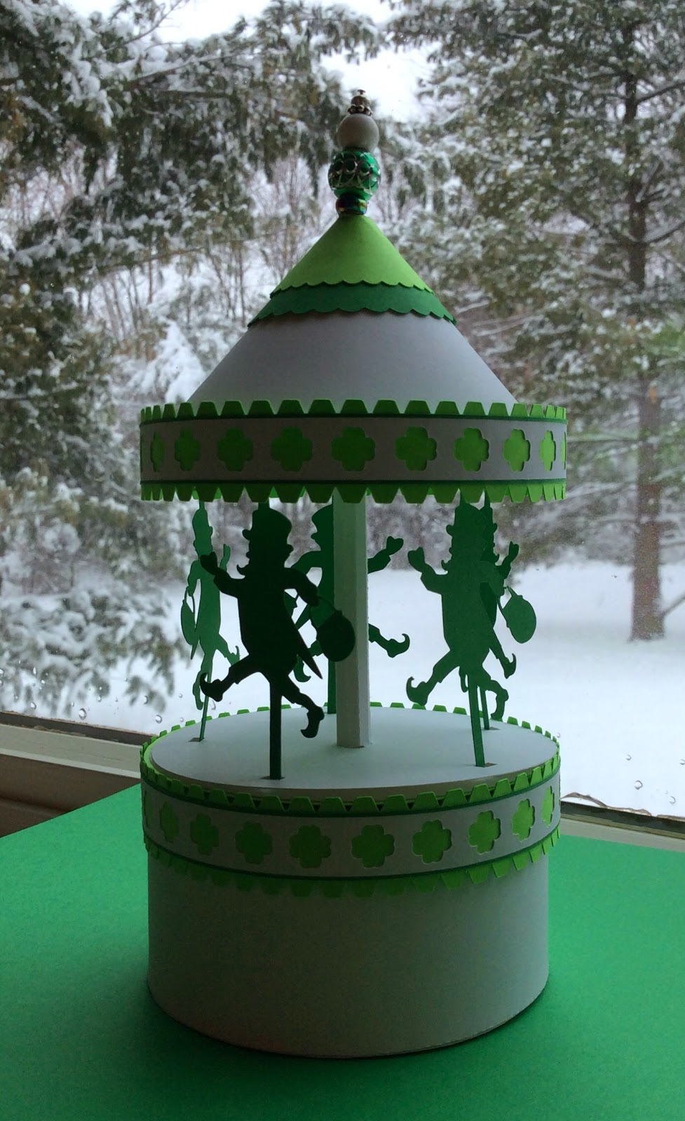

A Leprechaun Carousel Box (Notice the snow in the background. We had 10 inches of snow!)

Happy St. Patrick's Day. What a day...it's my 12th snow day this school year. I think I have had enough of winter and I am ready for spring. I modified my carousel from a previous post to reflect today's holiday. I think the leprechaun is adorable with the pot of gold in his hand. When the carousel spins, he is going around in circles...exactly what you would expect of a little magic elf.

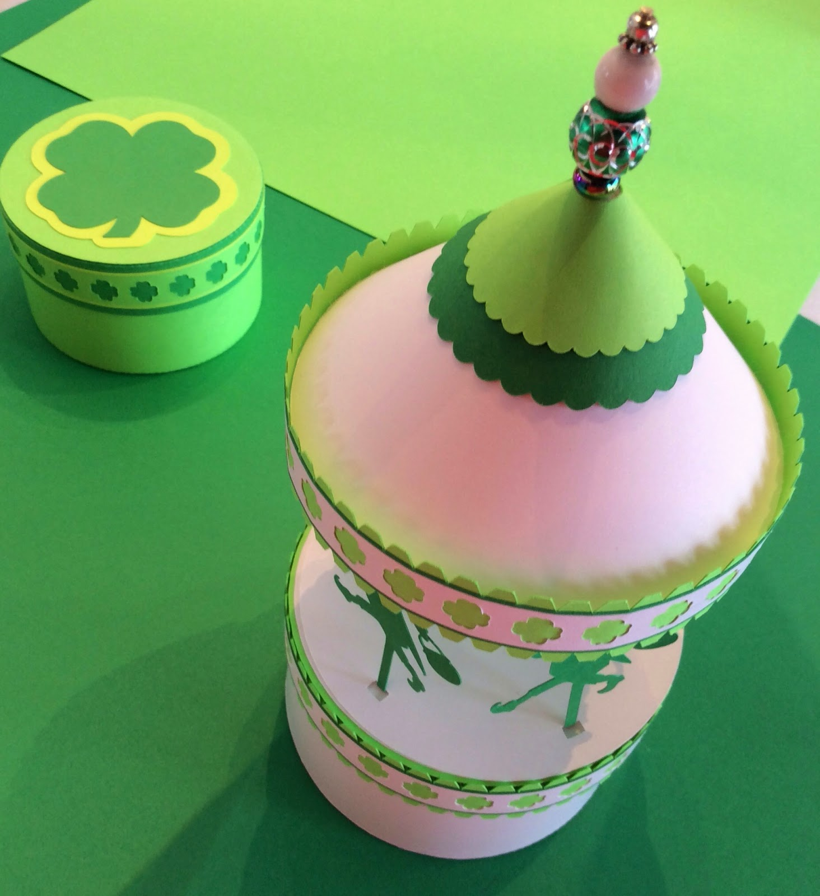

I added beads to the top of the carousel instead of a flag. The beads are strung together on a pin and glued to the axle of the carousel.

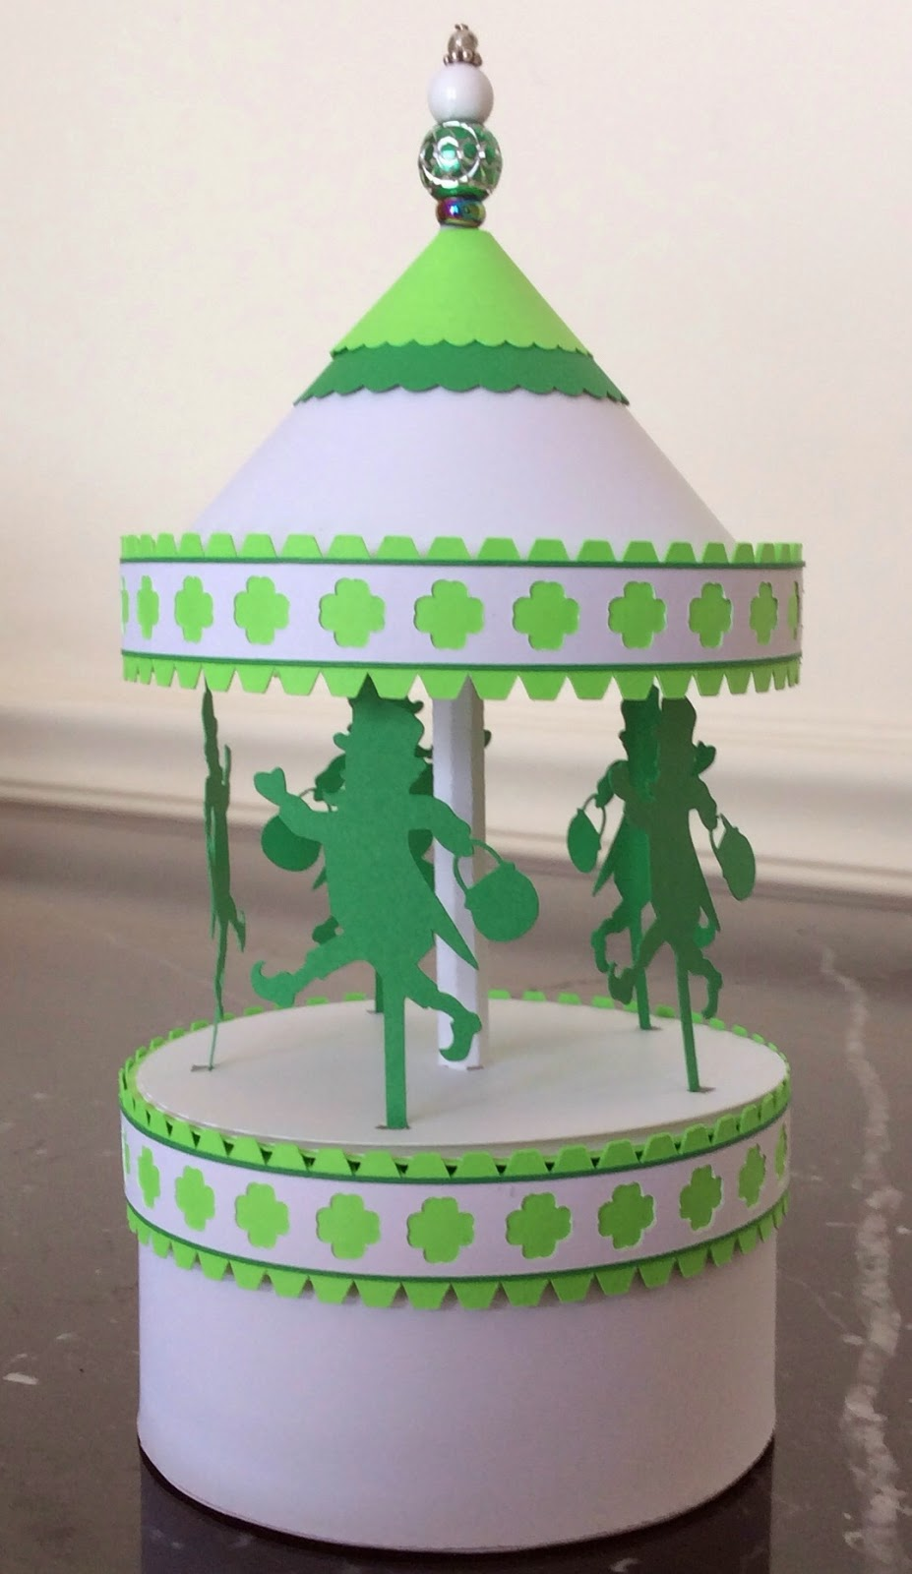

Everyone is Irish on St. Paddy's Day. Enjoy the day!